**TP MODUL 6**

**Nama : Ahmad Naufal Ramadhan**

**NIM : 103012300239**

**Kelas : IF-47-02**

**Kode Asprak : YDA**

DLL.h

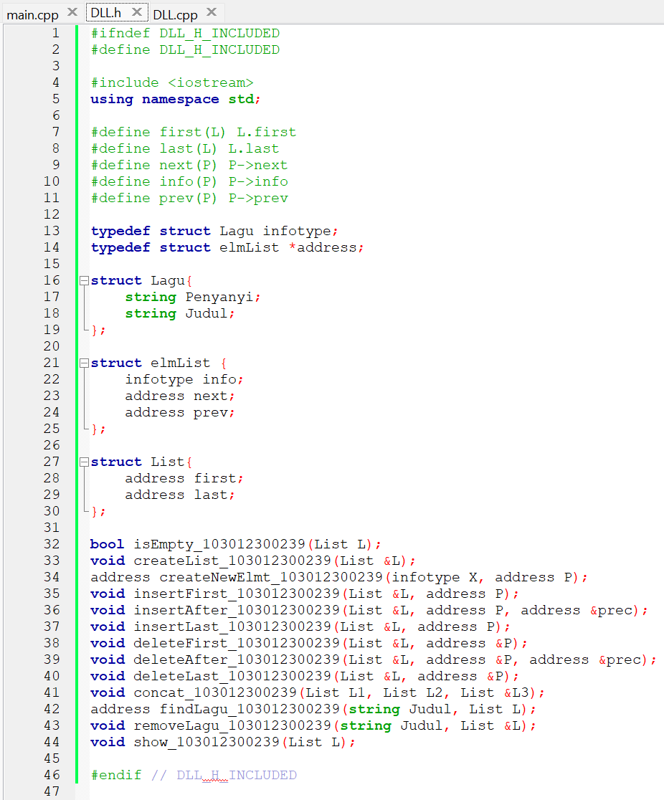

DLL.cpp

Main.cpp

Running

input

3

FosterThePeople Imagination

TheCorrs Radio

Maroon5 Sugar

GunsNRoses SweetChildO'Mine

HighwayToHell

SatuBulan

BohemianRhapsody

WelcomeToJungle

Sugar